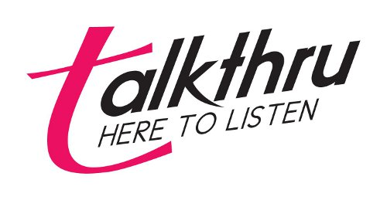Charity Number 1122488

**Charity Gift Aid Declaration**

Are you a UK taxpayer? **Boost your donation by 25p of Gift Aid for every £1 you donate**

You can use Gift Aid to make your donations go further by completing this declaration. If you Gift Aid your donation, Talkthru can claim Gift Aid tax relief of 25p on every pound you give. Talkthru is the working name of Huddersfield Pregnancy Crisis Centre.

Gift Aid is reclaimed by talkthru from the tax you pay for the current tax year. Your address is needed to identify you as a current UK taxpayer.

**In order to Gift Aid your donation you must complete the sentence below:**

I want to Gift Aid this donation of £______________ /*and any donations I make in the future or have made in the past 4 years to Talkthru (please delete as appropriate*)

I am a UK taxpayer and understand that if I pay less Income Tax and/or Capital Gains Tax than the amount of Gift Aid claimed on all my donations in that tax year it is my responsibility to pay any difference.

**My Details**

Title ____________________ First name___________________________

Surname ____________________________________________________________

Full Home address_____________________________________________________

____________________________________________________________________

Postcode __________________________ Date_____________________________

**Please notify Talkthru if you:**

• want to cancel this declaration

• change your name or home address

• no longer pay sufficient tax on your income and/or capital gains

If you pay Income Tax at the higher or additional rate and want to receive the additional tax relief due to you, you must include all your Gift Aid donations on your Self-Assessment tax return or ask HM Revenue and Customs to adjust your tax code.